Contest ID 1018
2016 NJCL Ancient Geography Test

1. Which of the following would NOT have been found in the Forum Romanum?
A. rostra B. Ara Pacis C. Curia Iulia D. Temple of Vesta
2. Which of the following Greek cities was the farthest SOUTH?
A. Sparta B. Athens C. Olympia D. Corinth
3. This was the port of Athens, and all goods bound to Athens were unloaded here.
A. Ostia B. Mylae C. Olympia D. Piraeus
4. This prison for holding prisoners was located in an old cistern near the Forum.
A. Iseum B. Mamertine C. Tabularium D. Temple of Saturn
5. What river did the Romans call the Sequana?
A. Saone B. Sava C. Seine D. Volga
6. Near which gate did Romans pass by the Tomb of the Eurysaces, the Baker?
A. Capena B. Querquetulana C. Maggiore D. Esquilina
7. Which of these deities did NOT have a temple in the Forum Romanum?
A. Vesta B. Apollo C. Saturn D. Concord
8. Whose stadium in Rome became the modern Piazza Navona?
A. Agrippa’s B. Gaius & Nero’s C. Domitian’s D. Flaminius’
9. On which hill would you have found the temple of Juno Moneta?
A. Palatine B. Aventine C. Esquiline D. Capitoline
10. Which city was known as Ratae Corieltauvorum?
A. Leicester B. Rouen C. Risafe D. Richborough
11. This island was the home of the Colossus, one of the ancient wonders of the world.
A. Sicily B. Rhodes C. Crete D. Cos
12. Which of the imperial fora was the smallest?
A. Nerva’s B. Vespasian’s C. Augustus’ D. Caesar’s
13. Which city did Constantine build as a “Christian Rome”?
A. Ravenna B. Theoroma C. Londinium D. Constantinople
14. Which port city in Italy bore the name of “elbow” in Greek?
A. Ancona B. Cumae C. Genoa D. Padua
15. Which region of Greece listed below was NOT part of the Peloponnese?
A. Arcadia B. Laconia C. Elis D. Locris
16. Which Greek island stretches the farthest north?
A. Delos B. Icaria C. Andros D. Samos
17. What ancient Roman province corresponds best to modern day Morocco?
A. Numidia B. Cyrenaica C. Mauretania D. Africa
18. In what ancient city would you find the Horologion of Andronikos Kyrrhestes?
A. Sparta B. Athens C. Pergamon D. Corinth
19. Which Greek city on the Peloponnese was closest to Corinth, and was also the place where Fulvia, wife of Marc Antony died in 40 BCE?
A. Megara B. Argos C. Mycenae D. Sicyon
20. What is the name of the sea directly east of Greece?
A. Ionian B. Aegean C. Cretan D. Tyrrhenian
21. Which Roman road went north from Rome, skirted the base of the Apennines, before rejoining another major road northwest of Pisae?
A. Via Cassia B. Via Aurelia C. Via Flaminia D. Via Clodia
22. Whose temple in the Forum Romanum contained the weights and measures?
A. Saturn’s B. Romulus’ C. Castor’s D. Vesta’s

23. Whose famous stone theater was located across the Tiber from Rome?
A. Agrippa’s B. Marcellus’ C. Pompey’s D. Herodes Atticus’
24. What did the Romans call the river running through Rome?
A. Eridanus B. Tiber C. Padus D. Ticinus
25. What did the Romans call the town where today you will find the Maison Carrée?
A. Avennio B. Massilia C. Narbo D. Nemausus
26. In which region of Italy were Cannae and Venusia?
A. Latium B. Calabria C. Apulia D. Lacania
27. Which modern nation was known as Hibernia by the Romans?
A. England B. Ireland C. Norway D. Denmark
28. Which modern body of water was known as Palus Asphalites by the Romans, who learned how to farm the bitumen floating on the water’s surface?
A. Red Sea B. Dead Sea C. Lake Cuomo D. Lake Trasimene
29. A visitor to Pompeii’s forum might have been struck by a building on the eastern side between the comitium and Vespasian’s temple. Which Pompeian funded its construction?
A. Caecilius B. Holconius C. Afer D. Eumachia
30. What was the sister city of Pompeii that was buried by hot mud after Pompeii’s destruction and entombment?
A. Herculaneum B. Ostia C. Neapolis D. Paestum
31. Which of the following is NOT an island in the bay of Naples?
A. Ischia B. Procida C. Pandateria D. Capri
32. Which of these cities does NOT border the Pontus Euxinus?
A. Cyzicus B. Heraclea C. Sinope D. Trapezus
33. What river ran through the tribal lands of the Iazyges?
A. Porata B. Danuvius C. Tisia D. Tyras
34. Which ancient city is located the farthest north?
A. Tolosa B. Narbo C. Massilia D. Aquae Sextiae
35. A large island in the eastern Mediterranean, also reputed to be the birthplace of Zeus.
A. Sardinia B. Crete C. Sicily D. Cyprus
36. What building on the Acropolis derives its name from the city’s mythical first king?
A. Eleusinium B. Erechtheum C. Propylea D. Pinakotheke
37. Once a year in September or October, a giant procession began in Athens and walked 25 km northwest up the Sacred Way to which of these cities?
A. Thebes B. Delphi C. Olympia D. Eleusis
38. Which is not one of the classic seven hills of Rome?
A. Vaticanus B. Aventinus C. Palatinus D. Viminalis
39. Which mountain chain is often called the “backbone of Italy”?
A. Alps B. Apennines C. Jura D. Pyrenees
40. Which of the following modern day countries was NOT part of Roman Dalmatia?
A. Albania B. Croatia C. Romania D. Montenegro
41. Which river’s water source was the farthest north?
A. Tiber B. Bagradas C. Tagus D. Iberus
42. According to Caesar, in which province would you have found the following tribes: Ausci, Tarbelli, Sotiates, Volcates, and the Bigerriones?
A. Aquitania B. Germania C. Celtica D. Belgica
43. According to Caesar, ubi sunt Ubii?
A. in Aquitaniā B. in Germaniā C. in Celticā D. in Belgicā
44. Which of the following was NOT located on the Palatine Hill?
A. Septizodium B. Meta Sudans C. Domus Flavia D. Romulus’ Huts
45. Which basilica in the Forum Romanum sat in the northeast near the Velian hill, and was built on the site of Rome’s spice warehouses?
A. Maxentius’ B. Julian C. Porcia D. Aemiliana

46. Which city lies the furthest north?
A. Mediolanum B. Verona C. Mantua D. Aquileia
47. Which lake was on the boundary of Rome and Parthia, and was named glittering, a puddle of water, and azure by other cultures, but Lacus Matianus by the Romans?
A. Erçek Gölü B. Lake Van C. Urmia D. Sevana Lich
48. Which city was NOT on the eastern coast of the Aegean Sea?
A. Ephesus B. Teos C. Kos D. Thessalonica
49. What did the Romans call the sea between the Bosporus and Dardanelles?
A. Marmora B. Marmara C. Propontis D. Euxinus
50. What northwestern Greek city-state had a favorite son and general named Pyrrhus?
A. Epirus B. Thessaly C. Macedonia D. Calcidice

PLEASE TURN TO THE NEXT PAGE.

For questions 51-55, please refer to the map of the Forum Romanum below.
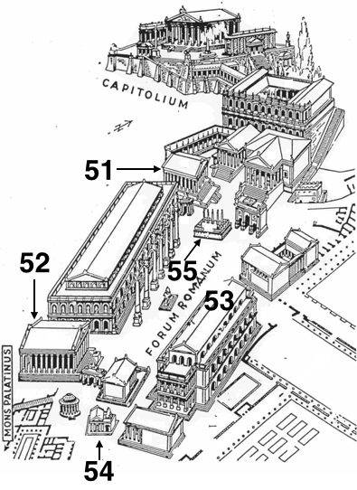

51. A. Temple of Saturn B. Temple of Castor
C. Temple of Vesta D. Temple of Concord

52. A. Temple of Saturn B. Temple of Castor
C. Temple of Vesta D. Temple of Concord

53. A. Basilica Ulpia B. Basilica Aemilia
C. Basilica Iulia D. Basilica Porcia

54. A. regia B. Lacus Curtius C. Carcer D. Temple of Vesta

55. A. rostra B. comitium C. Temple of Caesar D. Curia Hostilia

PLEASE TURN TO THE NEXT PAGE.

For questions 56-60, please refer to the map of ancient Rome below.
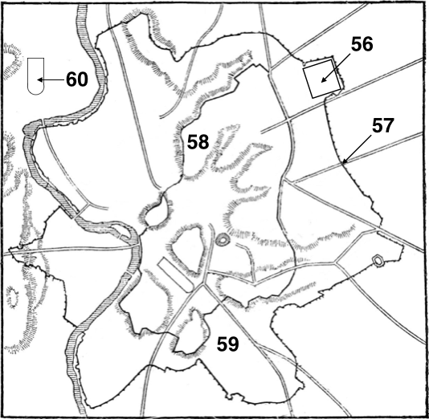

56. A. Theater of Marcellus B. Pantheon
C. Praetorian Camp D. Field of Mars

57. A. Porta Latina B. Porta Salaria
C. Porta Nomentana D. Porta Tiburtina

58. A. Viminal Hill B. Pincian Hill
C. Quirinal Hill D. Esquiline Hill

59. A. Baths of Caracalla B. Baths of Titus
C. Baths of Diocletian D. Baths of Agrippa

60. A. Circus of Nero B. Circus of Maxentius
C. Circus Maximus D. Circus Flaminius

PLEASE TURN TO THE NEXT PAGE.

For questions 61-70, please refer to the map of ancient Greece below.
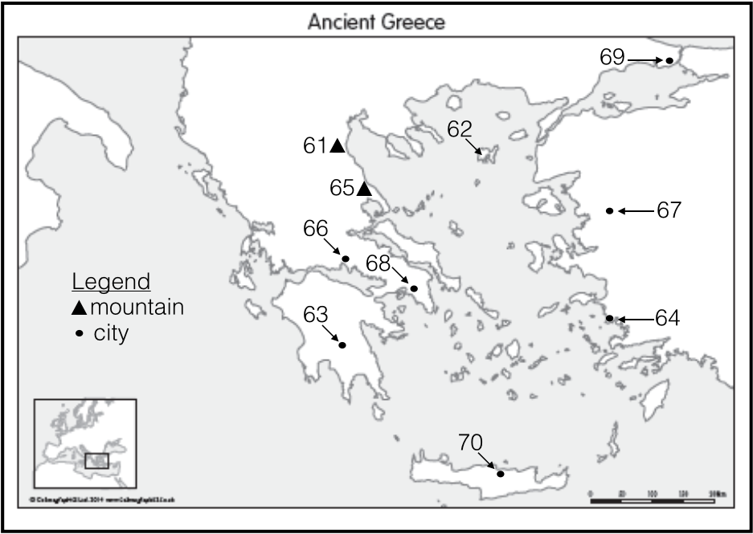

61. A. Mt. Helicon B. Mt. Olympus C. Mt. Ida D. Mt. Pelion
62. A. Lesbos B. Lemnos C. Tenedos D. Samothrace
63. A. Elis B. Argos C. Pylos D. Sparta
64. A. Ephesus B. Halicarnassus C. Miletus D. Lindos
65. A. Mt. Helicon B. Mt. Olympus C. Mt. Ida D. Mt. Pelion
66. A. Delphi B. Eleusis C. Piraeus D. Thebes
67. A. Troy B. Pergamon C. Herakleia D. Phocaea
68. A. Athens B. Mycenae C. Sparta D. Eretria
69. A. Troy B. Abydos C. Ophyrnium D. Byzantium
70. A. Zakros B. Gortyn C. Knossos D. Kissamos

PLEASE TURN TO THE NEXT PAGE.

For questions 71-80, please refer to the map of ancient Italy below.

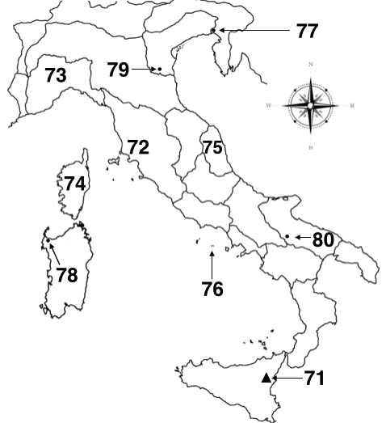

71. A. Ossa B. Vesuvius C. Aetna D. Algidus
72. A. Latium B. Etruria C. Calabria D. Umbria
73. A. Liguria B. Alpes Cottiae C. Picenum D. Alpes Maritimae
74. A. Sardinia B. Sicilia C. Corsica D. Capri
75. A. Picenum B. Aemilia C. Liguria D. Noricum
76. A. Ischia B. Pandateria C. Pontia D. Partenope
77. A. Aquileia B. Patavium C. Emona D. Virunum
78. A. Caralis B. Aleria C. Palma D. Turris
79. A. Ravenna B. Bononia C. Placentia D. Ancona
80. A. Asculum B. Arpi C. Luceria D. Cannae

PLEASE TURN TO THE NEXT PAGE.

For questions 81-95, please refer to the map of the Roman Empire below.
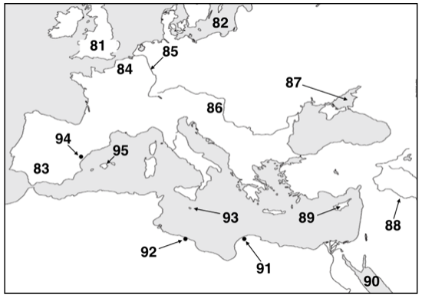

81. A. Caledonia B. Hibernia C. Britannia D. Anglia
82. A. Mare Scandium B. Mare Suevium C. Mare Germanicum D. Mare Itium
83. A. Baetica B. Lusitania C. Terraconensis D. Raetia
84. A. Lugdunensis B. Germania Inferior C. Belgica D. Aquitania
85. A. Rhenus B. Danuvius C. Albis D. Mussala
86. A. Noricum B. Pannonia C. Illyricum D. Raetia
87. A. Palus Maeotis B. Pontus Euxinus C. Mare Caspium D. Palus Atra
88. A. Euphrates B. Tigris C. Danuvius D. Danaper
89. A. Ithaca B. Crete C. Karpathos D. Cyprus
90. A. Sinus Africanus B. Sinus Arabicus C. Sinus Angustus D. Sinus Nasi
91. A. Cyrene B. Berenice C. Ptolemais D. Charotus
92. A. Leptis Magna B. Cyrene C. Cirta D. Caesarea
93. A. Melitene B. Melito C. Melita D. Melos
94. A. Tarraco B. Barcino C. Cartago Nova D. Saguntum
95. A. Balearis Major B. Balearis Minor C. Formentera D. Cabrera

PLEASE TURN TO THE NEXT PAGE.

For questions 96-100, please select the best answer.

96. Which mountain range, mentioned by Pausanias, separates Attica from Boeotia?
A. Parnes B. Pentelicus C. Aegaleos D. Diacria
97. Under Diocletian, what was the capital of Praevalitana?
A. Salonae B. Salapia C. Scodra D. Saepina
98. Which river, mentioned by Pausanias, marked a trade route from the Caspian and the Cyrus to Artaxata and Asia Minor?
A. Oxus B. Cyrus C. Phasis D. Araxes
99. This Lydian (or Carian, depending on what you read) city changed names several times, from Seleucia to the highly unoriginal Caesarea, was located on the north side of the Maender valley, and was first mentioned by Xenophon.
A. Tralles B. Mazaca C. Eusebia D. Phaselis
100. What western Greek island (and eponymously named main city) was the southernmost island located in the Ionian Sea, as well as a place of mild banishment?
A. Leucas B. Zacynthus C. Cephallenia D. Elis

